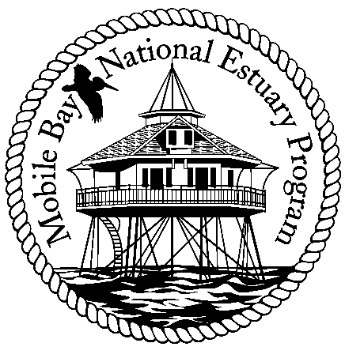

Mobile Bay National Estuary Program
Finance Committee Meeting February 18, 2008
Minutes

Attending: Bernie Fogarty, Steve Perry, Russell Ladd, David Yeager, Roberta Swann

The Finance Committee meeting began at 10:00 a.m. David Yeager announced that he would be stepping down as director of the NEP some time this summer and would continue with the program in a consultant capacity. One of his charges would be to assist the finance committee with raising non-federal match dollars for the program.

The finance committee decided to map out a plan for approaching local municipalities for contributions/annual investment in the MBNEP program based on a 25 cent per person allocation per municipality. Roberta Swann will "scrub" the list previously distributed to delete those areas that are not incorporated and verify population numbers to ensure that there is no double counting. Bernie Fogarty will go through the list previously provided by Ms. Swann and identify those officials that he knows.

Steve Perry handed out two sheets, MBNEP Funding Overview and Project Proposals and Funding to better understand the funding process of the NEP and where naming opportunities would fit in. Perry agreed to will develop a plan for approaching the business community. A discussion was had that revolved around the possibility of obtaining yearly donations from Forum/PEP/Chamber members and having the Forum/PEP provide a check each year to the MBNEP on behalf of the contributors. Although this would not raise a large amount of dollars, it would provide operational support to the program. The group discussed whether or not this small corporate contribution would preclude NEP from receiving larger one time amounts. No decision was made and Mr. Perry was asked to reflect on the different arguments in crafting his plan.

Russell Ladd suggested the creation of a video to bring more attention to the MBNEP and its activities. All supported this idea, while recognizing that this would be a difficult project to complete. Ms. Swann noted that the Exploreum was already in discussion with NEP to do some type of digital display of the NEP to include in their upcoming exhibit and that Sam St. John had contacted NEP with an interest and offer to assist with the development of a video that would educate about what the NEP does. His concept was to highlight projects and capture the universe of citizens involved in estuary conservation activities. David Yeager agreed to follow up on this project and investigate what possibilities exist.

David Yeager asked all present to please educate their lobbyists about the request for a state allocation under the education budget that would support the NEP's non-federal matching share. He stated that the line item is part of a DISL appropriation that includes the lab, NEP and Sea Grant. He agreed to get the Finance Committee members specifics on the line item which amounts to $250,000 for the NEP.

Steve Perry suggested that NEP apply to Legacy for funding of projects. Ms. Swann asked about the possibility of requesting funds for the creation of the video. Mr. Perry stated he thought that would fit within their guidelines.

Ms. Swann stated that on Tuesday and Thursday evenings of this week, the NEP would be holding public meetings to gather input and proposal requests for the upcoming program year. This is the first effort to develop a project inventory that could be used for future fund raising.

Tasks to complete before the next meeting:
Bernie- Get David a list of contacts for municipalities
Roberta- scrub list
Steve- conceptual plan on how to approach business
David- send specifics on line item to finance committee members and explore video development options

The next meeting will be the morning of March 10 pending availability of Randy Davis.

Meeting adjourned at 11:20 a.m.

