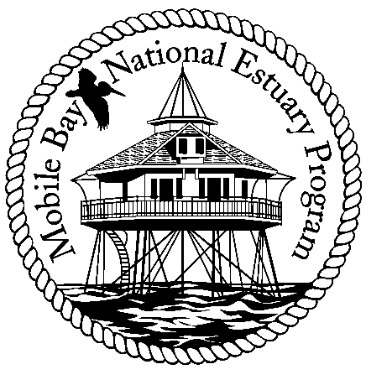

Mobile Bay National Estuary Program
Finance Committee Meeting March 7, 2008
Minutes

Attending: Bernie Fogarty, Steve Perry, Russell Ladd, David Yeager, Roberta Swann

The Finance Committee meeting began at 1:00 p.m. The purpose of this meeting was to map out a schedule of visits to municipalities for soliciting investments to the MBNEP program.

After a review of the Community Annual Investment Analysis prepared by NEP staff, the group decided the following:

1. David Yeager and another member of the Finance Committee or Management Conference will visit and make requests of the attached municipalities/county:

2. These visits will happen within the next three months. Capt. Yeager will work with his staff to schedule these appointments.

3. The meeting process should not last longer than 15 minutes. MBNEP staff will put together a packet that can be left with the person of the visit. It should include an NEP brochure, a fact sheet of the pertinent environmental issues facing that community, MBNEP accomplishments related to that community, and a list of the project requests for the current year.

David Yeager will work on a script that identifies one specific reason it is important for that community to invest, or one issue that ties the community to the NEP.

Meeting adjourned at 2:40 p.m.

