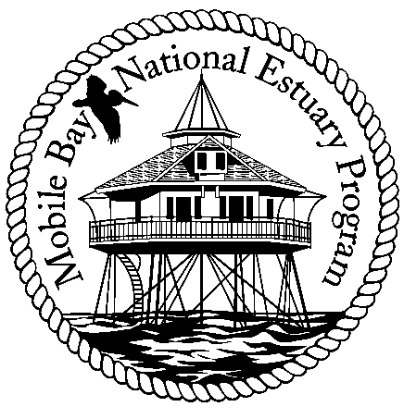

Mobile Bay National Estuary Program
Finance Committee Meeting April 22, 2008
Minutes

Attending: Bernie Fogarty, Steve Perry, Russell Ladd, Ron Hevernan, David Yeager, Roberta Swann

The Finance Committee meeting began at 9:00 p.m. The purpose of this meeting was to review the recommendations of all MBNEP Project Proposal Reviewers for the 2008-2009 program year and make financial recommendations to the Executive Committee for approval.

After a review of the scores/ranking of each of the project submitted, the group decided the following: Overall, projects rated #1, #2, or #3 were funded, referred to another funding source, or were not funded due to organizational capacity limitations. Project funding at this point totaled $302,560.00. From that point the finance committee reviewed projects based on their contribution to ongoing initiatives or their role in providing opportunities for MBNEP community partnerships.

1. Of the five projects rated #1 by reviewers, four were recommended for funding and the fifth was sent to the CAC for inclusion in their mini-grant program:
Fish River Studies: Alabama Coastal Foundation- $5,800
Auburn University- $35,533
Weeks Bay Foundation- $22,000
Eco tourist signage: Wolf Bay Watershed Watch- $51,000

The recommendation of the Finance Committee was that funding for the first three projects was to require all three entities to work together to create a coordinated project. Each proposal brought specific strengths to a larger project: Alabama Coastal Foundation is key to volunteer recruitment; Auburn University brings community education/outreach and graphical abilities to the project, and Weeks Bay Foundation/Weeks Bay Reserve focuses on the scientific research necessary to identify pathogen sources. The Finance Committee further recommended that Auburn be asked about their willingness to coordinate the project, bringing it together with a complementary project being conducted by Dr. Kalin at Auburn University to study nutrient loading in Fish River.

The fifth project, Water Testing in Dog River, was referred to the Community Action Committee for inclusion and review under the CAC Mini-Grant Program.

2. Of the four projects rated #2 by reviewers, all were recommended for funding at the requested level:
Clean Marinas: AUMERC/Sea Grant- $10,000
Blue Crab Habitat Study: Dauphin Island Sea Lab/Aronson-$49,813
Trash Curtain Installation: Dog River Clear Water Revival- $20,324
Sediment Loading Analysis: Town of Magnolia Springs- $34,250

3. Of the four projects rated #3 by reviewers, the following projects were recommended for funding:
Watershed Education: Clean Water Partnership (reduced funding)-$10,000
West Indian Manatee Monitoring: Dauphin Island Sea Lab/Carmichael-$29,726
Shoreline Stabilization-Helen Wood Dauphin Island Sea Lab/Heck- $34,114

The fourth project, to conduct public outreach, submitted by the Dog River Clear Water Revival, was not funded due to concerns about the organizations capacity, given that other projects to this group had been recommended for funding.

4. Of the five projects rated #4 by reviewers, only one project was recommended for funding:
Facilitation of Coastal Land Trust: Auburn University/CHCT- $4,140

5. Of the three projects rated #5 by reviewers, two projects were recommended for funding- one that opens up opportunities for partnering with the City of Bayou La Batre and one to support an ongoing initiative for monofilament recycling:
Community Planning Bayou La Batre: Auburn University- $17,000
Coastal Clean Oceans Initiative: Southeastern Wildlife Conservation Group- $5,814

6. Of the three projects rated #6 by reviewers, one project was recommended for funding to continue an ongoing initiative:
Beach Nesting Bird Survey: National Audubon Society- $5,500

7. No projects rated #7 were recommended for funding. Although there was some discussion about providing partial funding to Troy University and the University of Alabama at Birmingham for the project- Treatment of Invasive Species through Ballest Water: Use of Sonication and Advanced Oxidants to Treat Natural Assemblages, the committee decided that it did not meet selection criteria related to ongoing initiatives or MBNEP range expansion, so no funding was set aside for this project.

8. Of the three projects rated #8 by reviewers, two projects were recommended for funding- one to support an ongoing initiative and one that will create a partnership with the City of Satsuma:
Land Use Education for Professionals: grassroots, inc.- $5,000
Public Access Improvements: City of Satsuma- $12,105

No projects were funded that were ranked #9 or above.

The Finance Committee will submit this recommendation to the Executive Committee for final approval at its May meeting.

The meeting was adjourned at 10:40 a.m.

