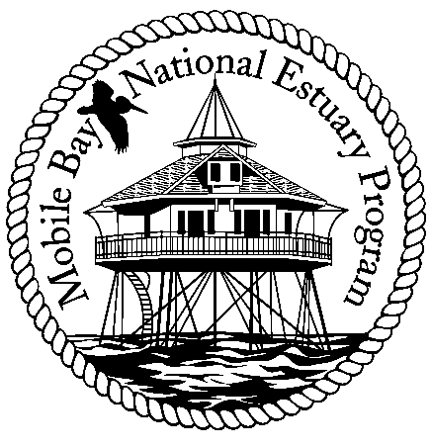

**Mobile Bay National Estuary Program**

**Finance Committee Meeting**

**Mobile Bay National Estuary Program Office**

**Agenda**

1. Update on Indirect and other Outreach Charges
2. Current Budget Reprogramming Items
   1. Mobile Bay Water Quality Model- Recommend Using Mobile County $
3. Work Plan for 2012-2013
   1. Estimates for State Funding , Mobile County, City of Mobile
4. Adjourn

Committee Members: Randy Davis, Phillip Hinesley, Jimmy Lyons, Eliska Morgan, Gloria Car