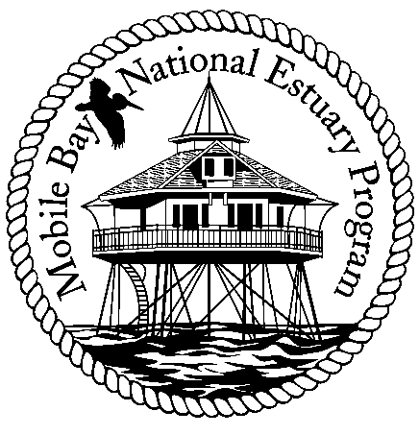

**Mobile Bay National Estuary Program**

**Finance Committee Meeting**

**Tuesday, April 10, 2012**

**Mobile Bay National Estuary Program Office**

**Agenda**

1. Update on Budget Reprogramming
   1. Mobile Bay Water Quality Model
2. Work Plan for 2012-2013
   1. Estimates for State Funding , Mobile County, City of Mobile
   2. Match Strategy
3. CERF Recommendations – Reprogram to restoration project
4. Adjourn

Committee Members: Randy Davis, Phillip Hinesley, Jimmy Lyons, Eliska Morgan, Darrelyn Bender, Gloria Car