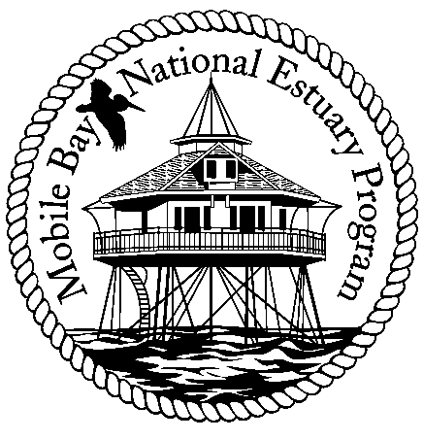

**Mobile Bay National Estuary Program**

**Finance Committee Meeting**

**Thursday, September 22, 2011**

**10:00 a.m.**

**Mobile Bay National Estuary Program Office**

**Agenda**

1. Develop alternatives to current “outreach” costs
2. Conduct an analysis of grant administration
3. Invitation to David England, Associate Director DISL Administration as ex-officio member of committee
4. Next Steps
5. Adjourn

Committee Members: Darrelyn Bender, Randy Davis, Phillip Hinesley, Jimmy Lyons, Eliska Morgan