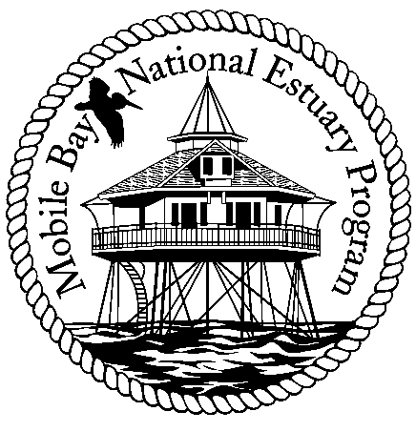

**Mobile Bay National Estuary Program**

**Finance Committee Meeting**

**May 14, 2013**

1.  Review Next Year Workplan for recommendation of approval by entire committee

a.  Discuss best use of MBNEP funding given other potential future funding opportunities (i.e., should we be focused on getting "shovel ready projects- more watershed plans, etc)

2.  Review Current Year plan amendments for recommendation of approval by entire committee

3.  Discussion regarding the proposed significant cut in funding from EPA and strategy for contact federal elected officials.  (NEP's took a disproportionate cut (15%) vs. EPA overall (5%).

4. New Lease for MBNEP-